Inmate Insight

Proyecto Final

Date: May 16, 2024

Authors: Coral S. Schmidt Montilla #148830 Gabriel o. Gonzales Rios #141406 Kevin G. Quintero Ramires #133009

Version: 1.0

Index

Abstracto 1

User Manual (English) 2

Menu: 2

Add Prisoner: 2

Modify Prisoner: 3

Search Prisoner 4

# Abstract

Efficient and secure management of prison data is critical for ensuring accountability and rehabilitation within correctional facilities. However, the lack of centralized database systems and reliance on manual methods pose significant challenges, including errors, inconsistencies, and security breaches. In response, the Inmate Insider project aims to address these issues by introducing a comprehensive solution that promises efficiency, security, and rehabilitation in prison management.

Key features of Inmate Insider, designed with your ease in mind, include a user-friendly interface for streamlined addition and modification of prisoner data, along with robust search functionality and database visualization tools. Objectives of the project encompass ensuring security and privacy, developing a user-friendly interface, and enhancing efficiency and accuracy in prison management processes.

The implementation plan involves collaboration with prison authorities for system integration and testing, conducting training sessions for effective adoption of the user interface by prison staff, and, most importantly, continuous feedback collection. Your input is crucial for further improvements and the success of the Inmate Insider project.

Moreover, to fulfill the project objectives, the program "Prison" will implement advanced programming concepts, including data encapsulation, instantiation of classes, inheritance, graphical user interface concepts, and database integration. The program will feature private attributes such as prisoner ID, name, last name, photo, birth date, physical attributes, place of birth, sentence details, and dates of conviction and liberation. The menu will include options for adding, modifying, searching for prisoners, displaying prisoner lists, accessing help contents, and viewing information about the program. Additionally, the program will utilize a database to store and retrieve prisoner information, integrating with an OpenFileDialog() class for photo selection.

# User Manual (English)

## Menu:

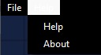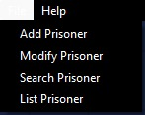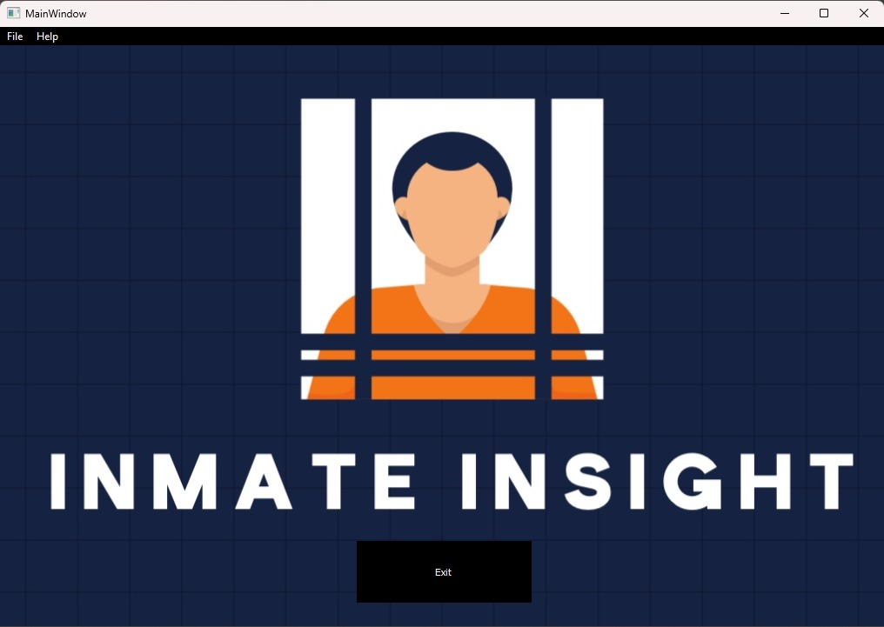\



Exit the program.



## Add Prisoner:

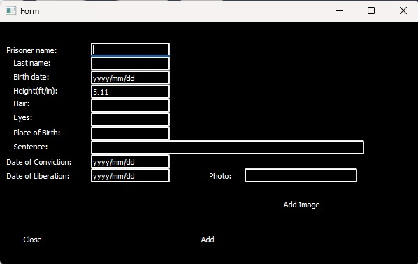Fill in al information of prisoner:

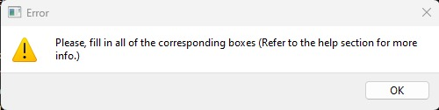If all information not filled:

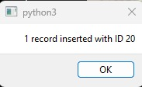When all information entered this will pop up as a confirmation, and give the prisoner its corresponding ID number:

## A screenshot of a computer Description automatically generatedModify Prisoner:

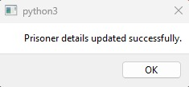When all information filled it will show and confirmation:

## Search Prisoner

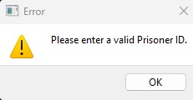If didn’t enter a valid ID This will pop up:

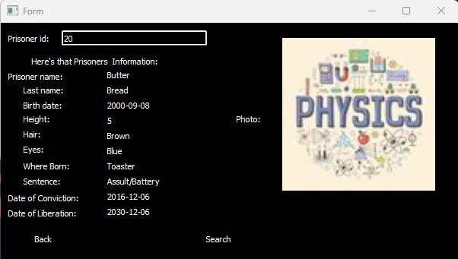This is an example of how it could show up as:

## Shows List:

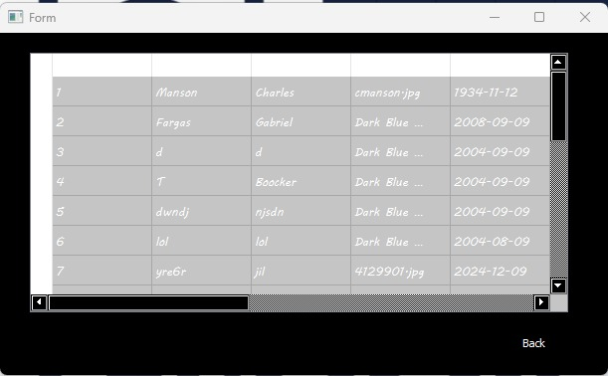This is an example of how it will look like:

## Help:

## About:

